Kyle Evangelisto

Professor Weissman

Lab06-A

05 October 2020

First Run:

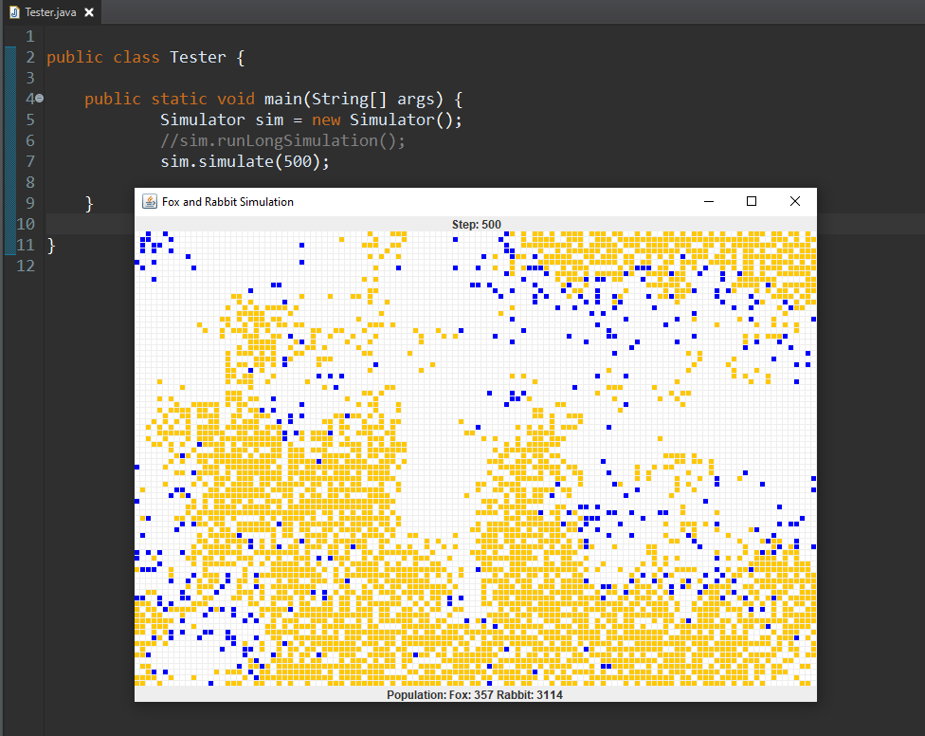

Second Run:

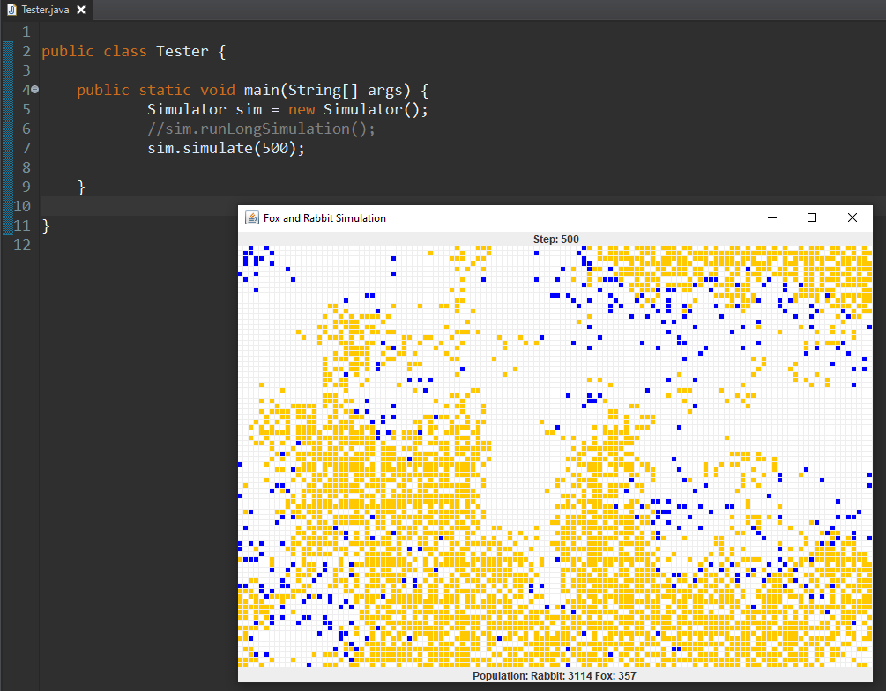

I did get the same values in both test runs.

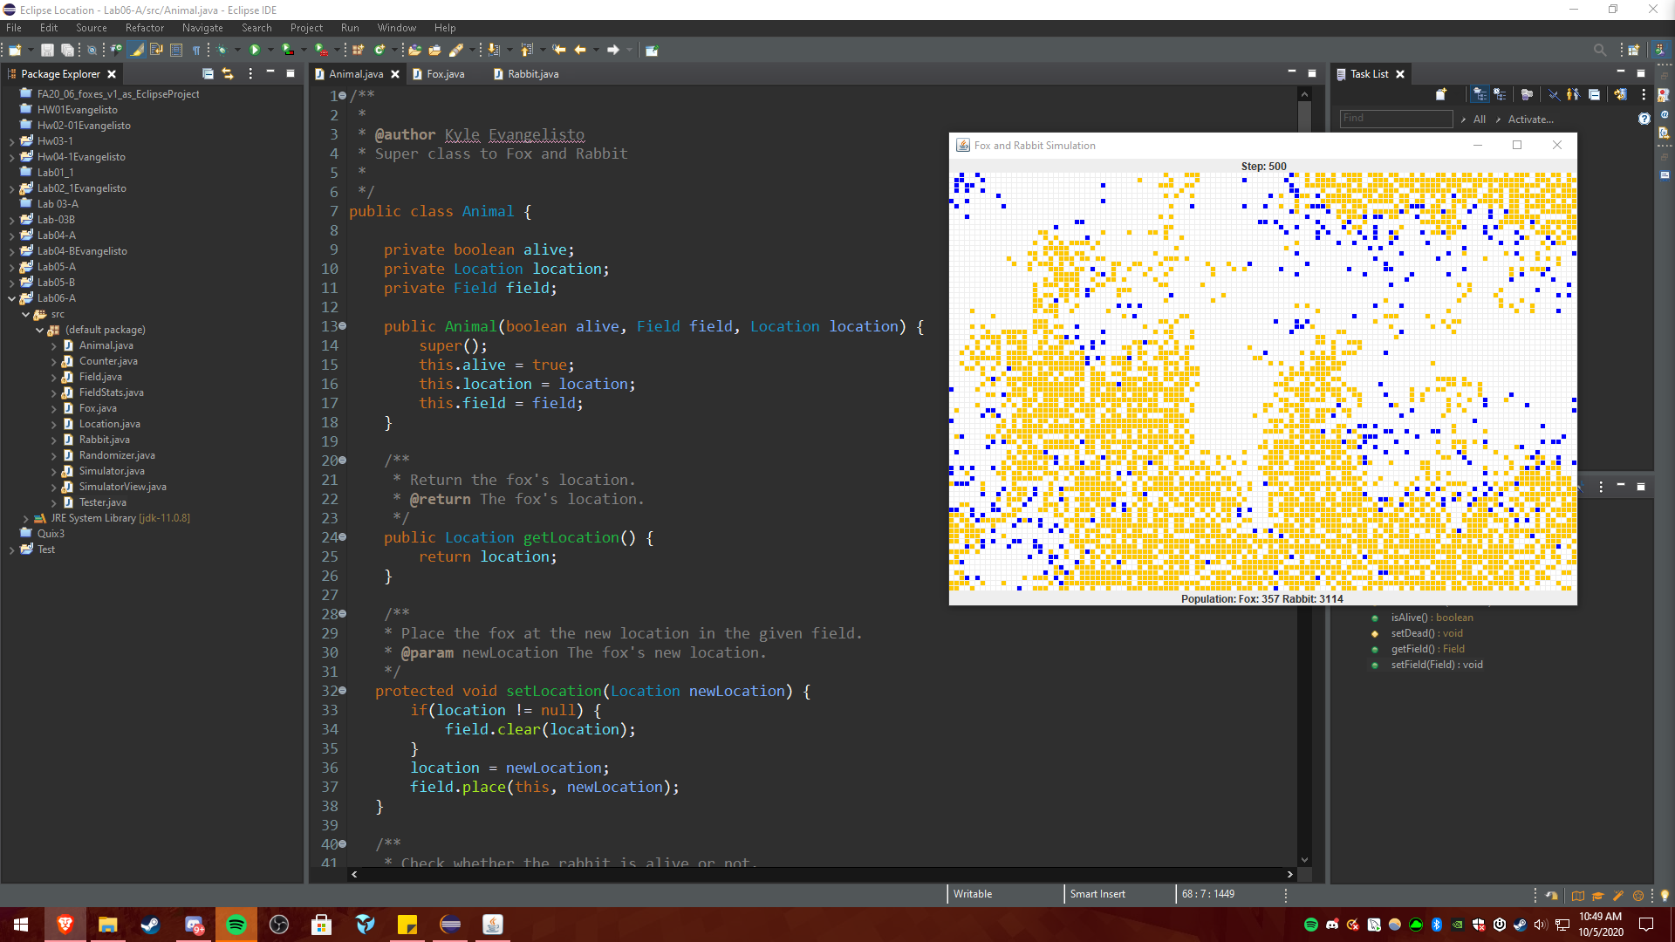

I got the same values after creating the Animal super class and removing duplicate code.